**Project** : Nurish

**Task** : how to raise/lower prices (<https://app.asana.com/0/1142139184125377/1150719951701498>)

**Goal** : When product prices changes, we need to update pricing on subscriptions and notify users.

**Workflow diagram :**

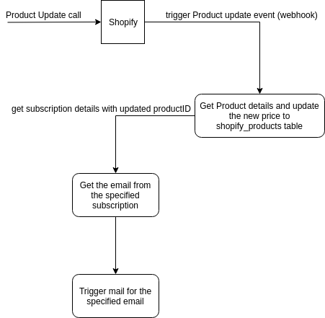

**Implementation Procedure** :

**Database**

Here we need to save the details of subscriptions and the shopify products in database in order to update the price of subscription and notify the user. Following are the tables that we are planned for implementing the feature

* shopify_products
* subscriptions
* subscription_products

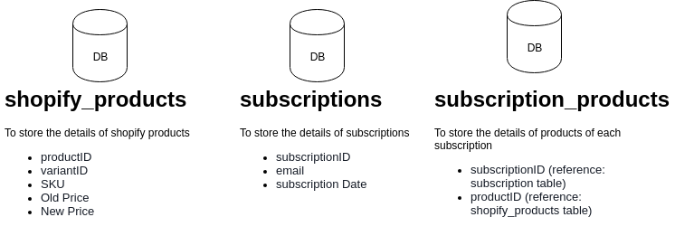

a) Why database is needed?

If we are storing the subscription details in DB along with the products from Shopify, we can easily fetch the subscription which is linked to the updated product.

Otherwise, it is difficult to get the subscription details since we need to check each subscription's product with this updated product for match. That's why we planned to set a new table for implementing this.

b) Advantage of using Database

* We can easily identify the subscriptions related to the updated product.
* No need of another API for fetching the user email (reduce unnecessary API calls)
* We can easily compare the price changes of the product (old and new price)

c) Data storing in tables

Initially we will fetch all the products from shopify and store the details in shopify_products table and also the subscription details in subscriptions table via API.

For newly created / updated subscriptions, we can trigger a webhook from recharge end. Similarly, we can set a webhook in shopify to store the newly created / updated product details to database.

**Plan**

We will set a webhook in Shopify (event: product update) which will trigger when a product get updated (price change). We will get the product details from this webhook and we can update the price field in the product table which is mentioned above.  
  
After updating the product details in the products table, we need to get the details of the subscription which is linked to that updated product. We can collect these details from the subscription_products table and will get the corresponding subscription details from the subscriptions table. From subscription details we will get the email of the user and we can trigger mail for the user and also we can update the price of the subscription from that.

